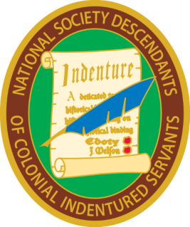

NATIONAL SOCIETY
DESCENDANTS OF COLONIAL INDENTURED SERVANTS

February 21, 2020

The Financial Review Committee has examined the records of the Treasurer General of the Descendants of Colonial Indentured Servants. This was a review of the checking account, bank statements and supporting documentation from January 1, 2019 to December 31, 2019. The Committee finds the records to be in good order and their contents to appear reasonable. The material appears to fairly represent the financial position and the income and expenses for the organization.

Susan Young Gray

