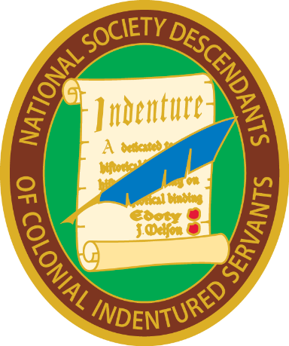
National Society Descendants of Colonial Indentured Servants
Historian General’s Report – 2020

President General Sumner Hunnewell sent a thumb drive with all of the documentation created by the Society from inception. A copy of the first directory and bulletin will be passed on to my successor.
Patricia Gallagher

