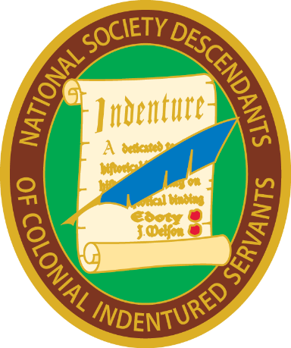
National Society Descendants of Colonial Indentured Servants
Recording Secretary General’s Report – 2020

This officer formatted the 2018-2021 Directory, maintained the Membership Spreadsheet and sent notices by email as requested by the President General.

Sharon Sowders, Recording Secretary General
National Society Descendants of Colonial Indentured Servants
3/18/2020

